Product Sheet
Proteinase K
Identifications:
Proteinase K is a broad substrate non-specific serine proteinase. It is very stable at pH 4-12. It was used on isolating mRNA, genomic DNA and digesting unwanted proteins during DNA and RNA preparations from different kinds of cells. It’s been used on glycoprotein modification and protein structure studies also. Proteinase K is active with SDS, urea and EDTA.
Form: Contains 100 mg Proteinase K, Lyophilized Powder
Specific Activity: 40 U/mg protein
Source: Tritirachium album limber
Molecular Weight: 29,730
Storage Conditions:
Store vial at 2-4ºC upon receipt. Dissolve and aliquot and store at -20ºC Recommended.
Expiration date is one year of powder and six months of sterile liquid at -20ºC to 4ºC. Use sterile filtration or add 0.5% NaN3 for liquid enzyme storage if keep it at 2-8ºC over a week.
Dilution Buffer: 50 mM Tris-Cl (pH 8.0) with 2 mM CaCl2.
QC Assays:
Unit Definition: One unit is defined as the amount of enzyme that will liberate 1 μmol of tyrosine per minute at 37ºC, pH 7.5.
DNase Activity: None detectable enzyme activity with λ DNA after 6 hrs incubation at 37ºC.
RNase Activity: None detectable ribonuclease activity after 16 hrs incubation at 25ºC.
References:
1. Kraus, E; et.al. Proteinase K from the Mold Tritirachium album limber, Specificity and Mode of
Action. Z. Physiol. Chem., 357:939;1976.
2. Jany,KD, et al. Amino Acid Sequence of Proteinase K from the Mold, Tritirachium album limber.
Proteinase K; a Subtilisin-related Enzyme with Disulfide Bonds. FEBS Letter, 199,139.1986.
Production & QC:
1. Product appearance:
2. Specific activity assay and stability assay:
(1) Specific activity assay (from Sigma-Aldrich):
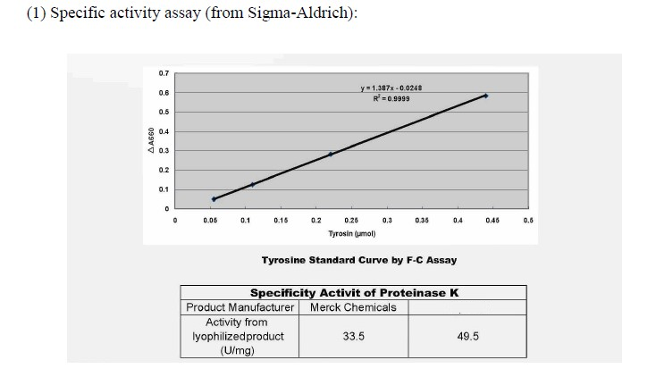

Aidlab

(2) Purity and protein digestion (SDS-PAGE):
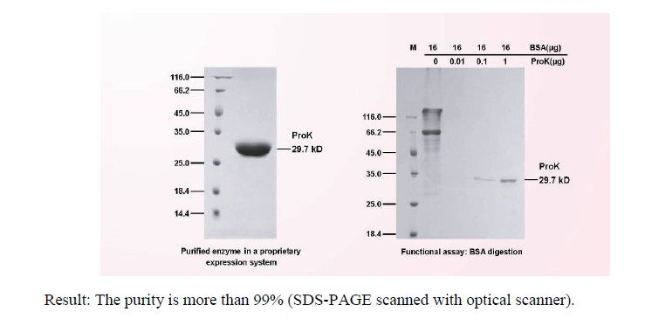

(3) Stability assay (one year)

